MOHAN SAI PRAGADA

mohansai.pragada2019@vitstudent.ac.in

**Assignment-2:**

Develop an "Automatic garage door opening system". Use an Ultrasonic sensor to detect if there is a vehicle in front of the garage. if any vehicle is detected open the garage door (rotate the servo motor) for some time and close it.

**Software:** Thinkercad

**Code:**

#include<Servo.h> Servo s; void setup()

{

s.attach(7);

pinMode(2, OUTPUT); pinMode(3, INPUT);

Serial.begin(9600);

}

void loop()

{

digitalWrite(2, LOW); digitalWrite(2, HIGH); delayMicroseconds(10); digitalWrite(2, LOW); float dur = pulseIn(3, HIGH); float dis = (dur * 0.0343)/2;

Serial.print("Distance in cm: "); Serial.println(dis); if(dis<100)

{

s.write(180);

delay(1000);

}

else

{

s.write(0); delay(1000);

}

}

**Before Simulation:**

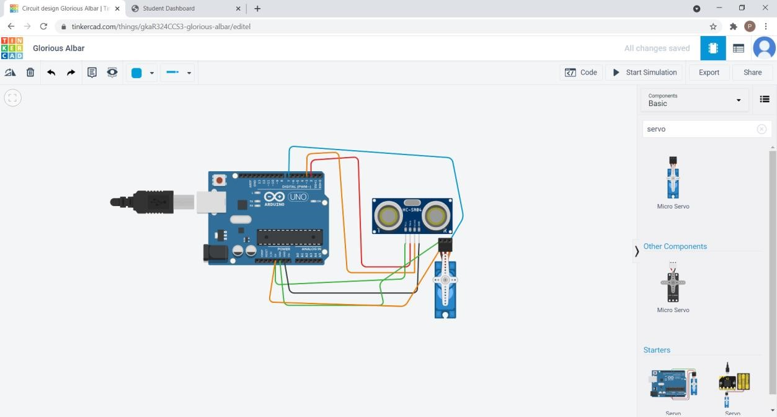

**After simulation:**

